**Documentation**

**Normal / Advanced Mode**

This is the user interface for Normal Mode (Left) and Advanced Mode (Right). Users may enter any set and calculate operations using the Buttons. The combo boxes are to switch the set position in the operation.

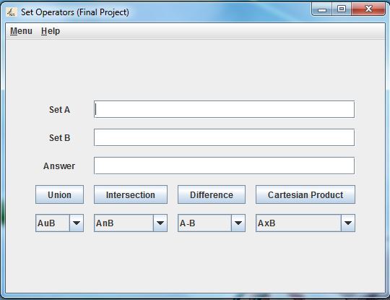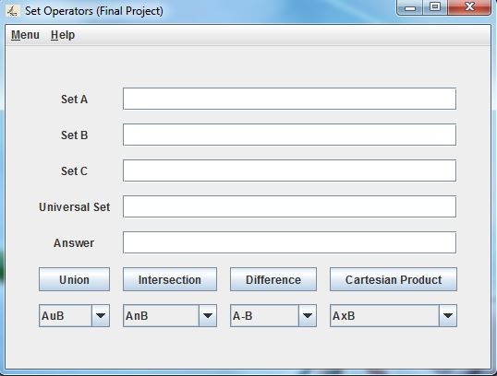

**Game Mode**

This is the application of the logic from Normal / Advanced mode and turned into a game / quiz that the user can take. Each question will ask a set operation and generate two random sets. It is the user’s task to figure out the correct answer. At the very end, the score will be shown with a corresponding trophy.

